076 CONSTITUENCY PARTY AGENTS FOR PHASE 2
WARD | 076 CONSTITUENCY CO-ORDINATOR | ALUSINE BB KAMARA | 030255233 | 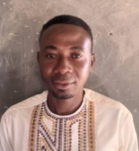
WARD 236 | 236 WARD CO-ORDINATOR | SANTIGIE M KAMARA |  | 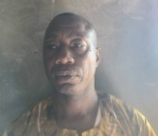
WARD 237 | 237 WARD CO-ORDINATOR | ISHMAEL SOW | 088269007 | 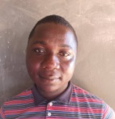
WARD 238 | 238 WARD CO-ORDINATOR | ALHAJI BANGURA | 079435332 | 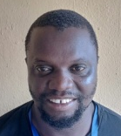
WARD CENTRE | PLACE | NAME OF PARTY AGENT | PHONE | PICTURE
236 | DEC PRIMARY SCH MAMANKIE | MAMUD KAMARA | 078005513 | 
236 |  | YUSUF KAMARA | 078955771 | 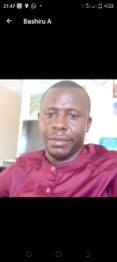
236 | COG PRIMARY SCH  ROSINT | OSMAN KING KAMARA | 030087432 | 
236 |  | ABU BAKARR TURAY | 077886076 | 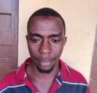
236 | AHMADIYYA SEC SCH SEH. TAGRIN | PRINCE COKER | 030533836 | 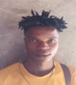
236 |  | ABASS WURIE | 073714336 | 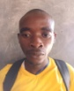
236 | KANKALAY PRIM SCH SUMBUYA LUNGI | ALIMAMY M BANGURA | 088521965 | 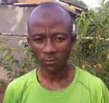
236 |  | MOHAMED M KAMARA | 077444717 | 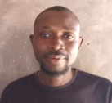
236 | SANAYA MEMORIAL ACADEMY ROBIS | MOHMOH T KAMARA | 099606245 | 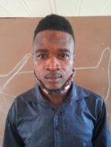
 |  | GIBRIL M KARGBO | 030514178 | 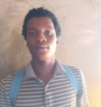
236 | DEC PRIMARY SCHOOL YALIE KAKUM | ALIMAMY M BANGURA 2 | 099577307 | 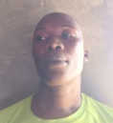
236 |  | FATMATA DUMBUYA | 099603500 | 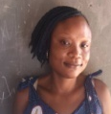
WARD 237/10041 | ANSARUL SENIOR SEC SCH ROTIFUNK LUNGI | MOININA KANNEH | 080677429 | 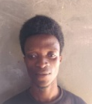
 |  | ALHAJI MOMOH KAMARA | 030875407 | 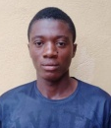
237/10041
237/10037 |  | ABU BAKARR SESAY | 077406693 | 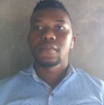
237/10037 |  | MARTIN TURAY | 079468383 | 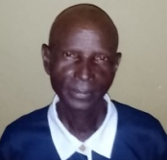
237/10035 | KINGDOM HERITAGE PRIMARY SCH BOMBEH | OSMAN A SANKOH | 034253932 | 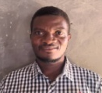
237/10035 |  | BAI BUREH KAMARA | 088881797 | 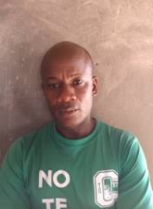
237/10296 | KINGS WAY INTERNATIONAL SE SCH BOMBEH | MOHAMED LAMIN KAMARA | 076046002 | 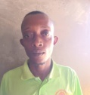
237/10296 |  | FATMATA A KAMARA | 099181049 | 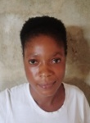
237/10039 | RC PRIMARY SCH YONGORO | ALUSINE BARRIE | 073438976 | 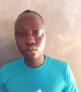
237/10039 |  | ALHAJI KAMARA | 030907700 | 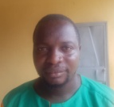
238/10043 | ST JOSEPH SEC SCH MASOILA | ISSA SILLAH | 077856604 | 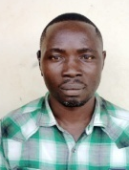
238/10043 |  | FODAY M KAMARA | 076279966 | 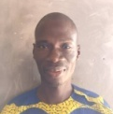
238/10045 | MISSIONARY CHURCH OF AFRICA ROYEAMA | JOSEPHINE S LAGGA | 088471776 | 
238/10045 |  | MOHAMED H KARGBO | 088772698 | 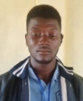
238/10047 | DEC PRIMARY SCH KASONGHA | MARY KOROMA | 079786844 | 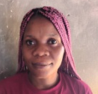
238/10047 |  | ABU M KAMARA | 088379120 | 
238/10049 | KRD PRIMARY SCHOOL ROYEAMA | FODAY M FOFANAH | 076648856 | 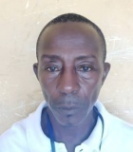
238/10049 |  | ZAINAB M BANGURA | 074857972 | 
238/10072 | PC BAI SHEBURAH COURT BARRAY ROTIFUNK | BAI BANGURA | 088757831 | 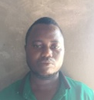
238/10072 |  | IDRISSA KAMARA | 079307463 | 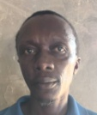

076 | MANAGEMENT COMMITTEE
 |  | LEONORA SMITH | 099273943
 |  | MR PATRICK FREEMAN | 075432998
 |  | MOHAMED S KAMARA | 078976997
 |  | ALEX JARFOI | 078890042
 |  | FODAY S KABBA | 076616765

